Experiment No – 5

Title / Aim :- Apply array methods & object handling ; Creating a cart total calculator with discount logic.

Software/Tools Required :-
- Visual Studio Code (VS Code)
- Google Chrome / Any Web Browser
- HTML
- JavaScript

THEORY :-
JavaScript arrays can store multiple product objects containing properties such as name, price, and quantity. The reduce() method is used to calculate the cart subtotal by multiplying price and quantity for each item. A percentage-based discount is applied according to the subtotal, followed by a 5% tax on the discounted amount. HTML provides the structure, CSS provides styling, and JavaScript handles the cart and billing operations dynamically.
OUTPUT:-
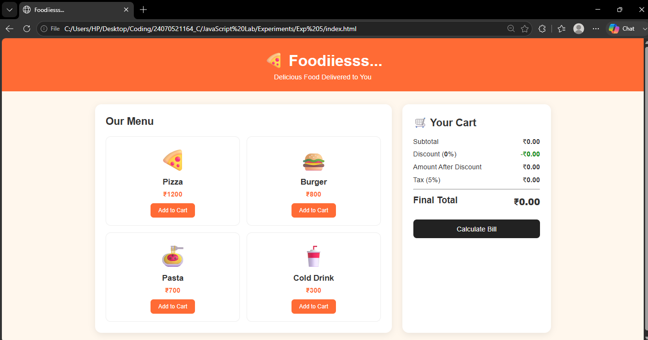



Result / Conclusion :-
The FoodCart webpage was successfully developed using HTML, CSS, and JavaScript. It calculates the subtotal using reduce(), applies the appropriate discount, adds 5% tax, and displays the final bill when the user clicks Calculate Bill.

